A much better approach is to create/use a group for Ansible administrators.
For example, as root:
groupadd ansibleadmin
Add ansible to it:
usermod -aG ansibleadmin ansible
Change the file's group:
chown root:ansibleadmin /etc/ansible/hosts
Give the group read/write permission:
chmod 664 /etc/ansible/hosts

Ansible Inventory
1. What is Ansible Inventory?
Ansible Inventory is a file that contains information about the managed machines (client machines) that Ansible will manage.
In simple words:
Inventory tells Ansible which machines it needs to manage.
For example, if you have two client machines:
ansibleclient1
ansibleclient2
You can add them to an inventory:
[dev]
ansibleclient1
ansibleclient2
Here, dev is a group name and the two machines are members of that group.

2. Why do we use Inventory?
Ansible needs to know:
- Which machines should it connect to?
- What are the hostnames or IP addresses?
- Which machines belong to which group?
- Are there different types of servers, such as development, testing, or production?
For example:
Ansible Manage Node
|
Inventory
|
┌──────────────┴──────────────┐
↓ ↓
[dev] [prod]
| |
client1, client2 server1, server2
Instead of specifying every machine each time, we can use a group name.
For example:
ansible dev -m ping
This tells Ansible:
Run the ping module on all machines belonging to the dev group.

3. What language is used in an Inventory file?
Ansible inventory can be written in different formats.
The most commonly used traditional inventory format is INI format.
Example:
[dev]
ansibleclient1
ansibleclient2

[prod]
webserver1
webserver2
It looks similar to a configuration file.
Ansible also supports YAML-based inventory and other inventory formats/plugins, especially for dynamic inventories.
For basic Ansible learning, INI format is the easiest to understand and commonly used.

4. Default Inventory File
The traditional default inventory file is:
/etc/ansible/hosts
You can open it using:
vi /etc/ansible/hosts
Example:
[dev]
ansibleclient1
ansibleclient2

[test]
ansibleclient3

[prod]
ansibleclient4
Here:
Group | Hosts
dev | ansibleclient1, ansibleclient2
test | ansibleclient3
prod | ansibleclient4
You can check the hosts in a group using:
ansible --list-hosts dev

5. Types of Ansible Inventory
There are two major types:
- Static Inventory
- Dynamic Inventory

5.1 Static Inventory
A static inventory is a manually maintained inventory file.
You manually add and remove machines.
Example:
[dev]
ansibleclient1
ansibleclient2

[prod]
webserver1
webserver2
If a new server is created, you need to manually add it to the inventory.
Example
Suppose you create a new AWS EC2 server:
10.0.0.10
You manually add:
[dev]
ansibleclient1
ansibleclient2
10.0.0.10
Advantages
- Simple
- Easy to understand
- Good for small environments
- Easy for learning and testing
Disadvantage
In a large environment with hundreds or thousands of servers, manually maintaining the inventory becomes difficult.

6. Dynamic Inventory
Dynamic inventory automatically obtains information about machines from an external source.
For example, in AWS, you may have many EC2 instances.
Instead of manually writing:
[dev]
server1
server2
server3
server4
server5
Ansible can obtain the information from AWS using an appropriate inventory plugin.
7.Adding Hosts with Custom Ports and Users
Normally, Ansible uses:
- SSH port: 22
- SSH user: the current/default user
But sometimes a server uses a different SSH port or you want Ansible to connect as a particular user.
Basic Syntax
[dev]
server1:22 ansible_user=sam
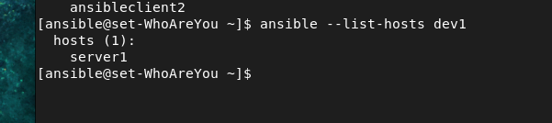
Here:
Part | Meaning
server1 | Hostname or IP address of the managed machine
:22 | SSH port
ansible_user=sam | Connect to the server using the sam user
So this means:
Connect to server1 using SSH port 22 and log in as user sam.

Example with a Custom SSH Port
Suppose your server's SSH service is running on port 2222:
[dev3]
server1:2222 ansible_user=sam
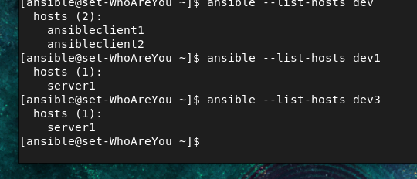
This means:
Server → server1
SSH Port → 2222
SSH User → sam
Ansible will effectively connect like:
sam@server1
|
└── SSH port 2222

Example with Multiple Servers
[dev]
server1:2222 ansible_user=sam
server2:2223 ansible_user=rahul
server3:22 ansible_user=ansible
Each server can have a different user and port.
Host | SSH Port | User
server1 | 2222 | sam
server2 | 2223 | rahul
server3 | 22 | ansible

Using IP Address
You can also use an IP address:
[dev4]
192.168.1.10:2222 ansible_user=sam
192.168.1.20:22 ansible_user=rahul

Important: server1:22 vs ansible_port
Both approaches can be used, but for teaching and more explicit configuration, you can also write:
[dev]
server1 ansible_port=2222 ansible_user=sam

8. Using Host Ranges in Ansible Inventory
Ansible allows you to define multiple hosts using a range pattern instead of writing every host separately.
This is useful when you have many servers with sequential IP addresses or hostnames.

1. IP Address Host Range
Suppose you have servers:
192.168.10.1
192.168.10.2
192.168.10.3
...
192.168.10.20
Instead of writing all 20 IP addresses, you can use a range:
[group]
192.168.10.[1:20]
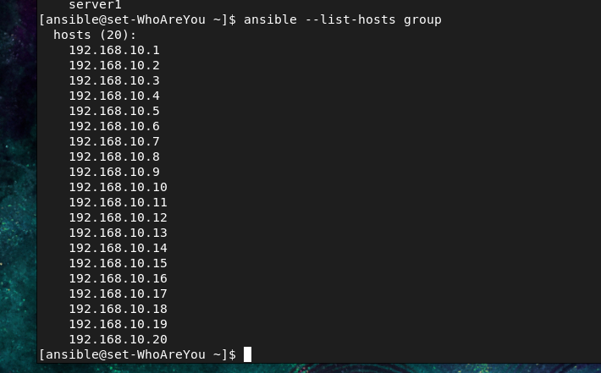

Complete inventory
[group]
192.168.10.[1:20]
This represents:
192.168.10.1
192.168.10.2
192.168.10.3
192.168.10.4
...
192.168.10.20

Check the hosts
Run:
ansible --list-hosts group
You should see:
hosts (20):
192.168.10.1
192.168.10.2
192.168.10.3
192.168.10.4
...
192.168.10.20

Important correction
Do not write:
192.168.10.1[1:20]
The correct syntax is:
192.168.10.[1:20]
Because [1:20] is the range that Ansible expands.

2. Hostname / Domain Range
You can also use ranges in hostnames.
Suppose you have:
gorakh01.example.com
gorakh02.example.com
gorakh03.example.com
...
gorakh10.example.com
You can write:
[server]
gorakh[01:10].example.com
Ansible expands this into:
gorakh01.example.com
gorakh02.example.com
gorakh03.example.com
gorakh04.example.com
gorakh05.example.com
gorakh06.example.com
gorakh07.example.com
gorakh08.example.com
gorakh09.example.com
gorakh10.example.com
Then check:
ansible --list-hosts server
Expected:
hosts (10):
gorakh01.example.com
gorakh02.example.com
gorakh03.example.com
...
gorakh10.example.com
